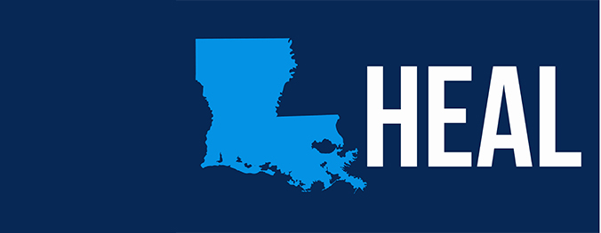
M. Maitland Deland, MD
Board Chair

Kurt M. Weigle
Vice Chair

Ronald J. French, MD
Secretary

M. Cleland Powell, III
Treasurer

Claudia Cavallino, DDS
Board Member

Walter “Chip” Flower, III
Board Member

Juan Gershanik, MD
Board Member

Dolleen Licciardi, MD
Board Member

Eileen Mederos, RN
Board Member
Sandra L. Robinson, MD
Board Member

Jay Shames, MD
Board Member

Carroll W. Suggs
Board Member

Jacob Johnson, MPA, CLED
Executive Director

February 19, 2016

NOTICE OF PUBLIC MEETING
DHH – Health Education Authority of Louisiana

A meeting of the HEAL Legislative Committee has been scheduled for:

March 4, 2016
10:00am
HEAL Office
300 LaSalle St., Suite B
New Orleans, LA

Corner of LaSalle & Gravier Sts.
Ground Floor of the HEAL/Standard Parking Garage

Please notify this office at (504) 568-5835 or e-mail Nathan Fontaine at Nathan.Fontaine@la.gov if a representative plans to attend.

